EV Charging Point Stops

(What to do while you wait?)

Vuyo Ndayi

# Introduction

As the electric vehicle (EV) steadily creeps its way into the car market, more and more EV charging points are also popping up in and around cities and towns. This means that soon (if not already) EV owners will be able to conduct their necessary daily commutes as well as the occasional leisure road trip without the concern of running out of battery power along the way. Considering thecurrent EV battery charging times which are relatively long when compared to the time one would usually wait to fill up a tank of fuel, as well as the average range of an EV in terms of distance, a question arises of what one should do with the time available while they wait for their EV to charge in between stops.

## Background

The growth in the electric vehicle (EV) market over past five to ten years has seen a broadening pool of electric vehicle owners. Once seen as an elitist vehicle model reserved for those who could afford the "green" status of owning an electric or hybrid vehicle, government subsidies into the market owing to global emission reduction commitments, have seen the cost of purchasing an EV driven down to be in reach of the everyday person (broadly speaking) [1].

Focusing on my own back yard, South Africa (RSA), there is still a degree of scepticism amongst those interested in purchasing an EV about the charging infrastructure around the country [2]. That is, outside of a dedicated plug point at one’s home, where can the EV be charged while on the road especially on long distance trips? The average EV available in RSA at the moment has a range of between 300 km - 500 km on a full charge. The average inter-provincial trip (or daily commute in some cases) will thus require a recharge at some point along the way. Added to this is the time required to charge an EV which can be anything between 20 minutes to 2 hours or longer depending on the charging point type and EV battery capacity [3]. For this reason, among others, there has been a relatively slower uptake of the EV in the private and commercial vehicle market.

## Problem description

There has, however, been a great deal of investment made by car manufacturers who offer EVs in the RSA market to build up the vehicle charging plug point infrastructure around the country [2]. Some of these manufacturers have maps on their respective websites showing their charging point locations and operating conditions [2]. The site plugshare.com offers the service of showing all the different plug point locations around the country and the rest of the world [3]. Information about the plug point such as the type, activity, nearby amenities and trip planning is also offered on the site. A layer of information that is useful and could be added to these plug point maps is detail on nearby venues where users could spend their time while waiting for their EV to charge. This project aims to address this in a simplistic solution.

# Data description and application

The data that will be used for this solution consists of the location data of a charging point as well as different venues within a walking distance (radius chosen as 200 m) from the charging point. This solution will, as discussed in the problem description, focus on the South African EV charging infrastructure on public routes.

## Data acquisition

The first part of the data required is the location of public EV charging stations in RSA. This information could potentially be available through accessing the PlugShare Developer Centre to retrieve EV plug point locations in a specific region. The siteonly offers commercial licence access to its API at this stage. It was decided that this is not a viable option for the scale and objective of this project. The alternative suitable for this project is a car magazine website article which lists a few of the EV charging stations in the country at the time of its publication (1 June 2017) [5]. The article provides the address of each plug point available. This address will be used to determine the latitude and longitude coordinates of the plug point using the Geocoder API.

The second part of the data required are the venues in the immediate surroundings of the plug point location. These venues can be acquired using the FourSquare API based on the plug point location data using a venue range radius of 200 m.

## Data application

The location data of the plug points and the respective surrounding venues will be plotted as markers on a map showing the plug location marker and the venues in its' surrounds.

The venues will then be clustered or grouped showing the user the number of venues near or around an EV plug point. Each plug point will also show the most common venue type near its location giving the user a quick overview of the venue information.

This will allow a user to see what types of venues are available near a certain EV plug point giving them options when deciding what to do while they wait for the vehicle to charge. A user could for instance decide to not stop at a certain plug point but rather at another which is close by or within range of their vehicles available battery capacity depending on venue type preference.

# Methodology

## Charging point data frame

### Charging point locations

A list of EV charging points were scrapped from the car magazine website, cars.co.za, from an online article called: EV Charge Stations in SA: How Many & Where? After an initial search of the charging point addresses using the. OpenStreetMapNomantim API, it was found that much of the addresses did not return the location data of the charging points. The Bing Maps API was chosen as an alternative since the Google Maps Platform carries a fee. A Bing Basic API key was created for this.

The data scrapped from the car magazine article was found to be outdated (the article was originally published on 1 June 2017) and thus did not represent latest data on the charging points is RSA. The charging points list was supplemented with a manual insertion of additional points taken off the PlugShare website. This provided a relatively more accurate list to work with and a better overview of the charging points across the country.

Using geocoders, the list of charging point addresses was used to get their location coordinates.

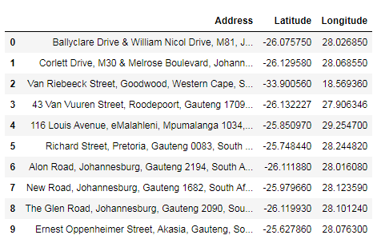

Figure 1: Charging point addresses and coordinates data frame head 10)

### Charging point Venues

Venues within a 200 metre radius of each charging point location were determined using the FourSquare database of venues. Each applicable venue’s, name, coordinates and category were associated with the corresponding charging point as shown in the table below.

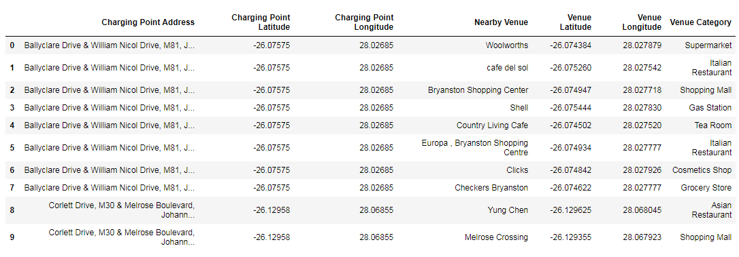

Figure 2: Charging point venues, coordinates and venue category data frame head (10)

## Extracting info useful to the user

### Common venues near charging point

It was decided that the most common venues near a charging point would be useful information for the traveling EV user. The most common venues near a charging point provide an overview of what kind of venues the user can expect to find nearby. With this knowledge, the user can decide whether they would like to stop at that charging point or rather another suitable one with their required amenities nearby. The algorithm used in previous exercises in the course was used to extract this information.

In general the most common venues near the charging points are eateries such as restaurants and cafes. This means the user could spend the time while waiting for their EV to charge getting a bite to eat or refreshment. There are also hotels in the nearby vicinity of some points should the user decide on an overnight stay.

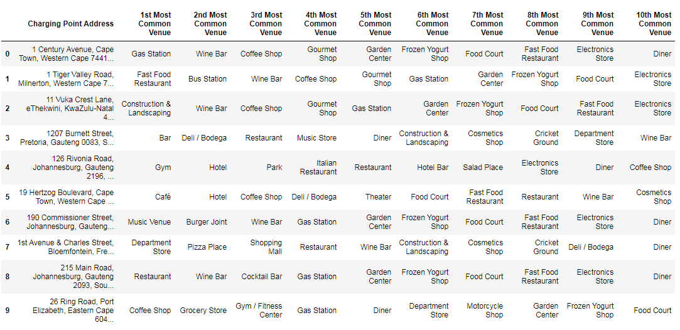

Figure 3: Most common venue types near each charging point data frame head (10)

**Charging points map**

### Charging point locations

Each charging point was plotted with a marker at its location on the RSA map using Folium. To add detail, the charging point name and the most common venue type near the point were added as marker labels.

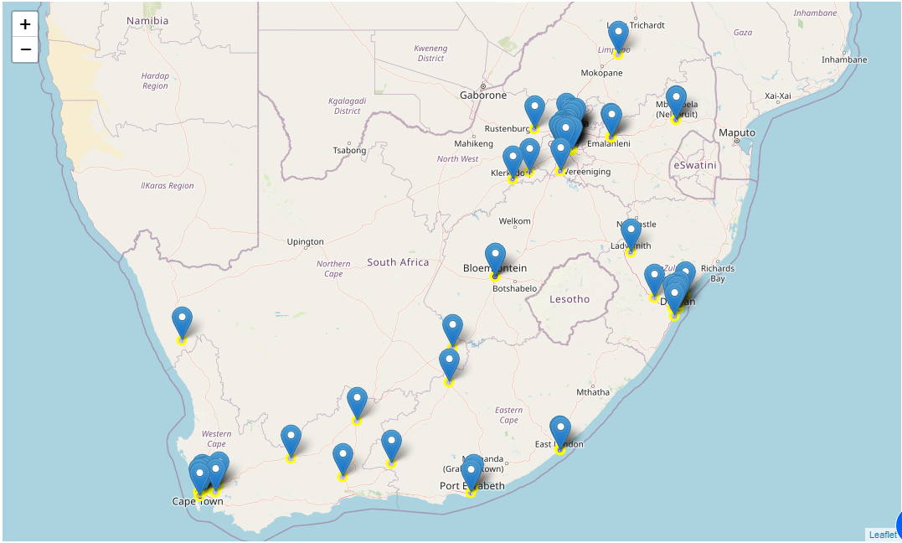

Figure 4: Map showing EV charging points across RSA

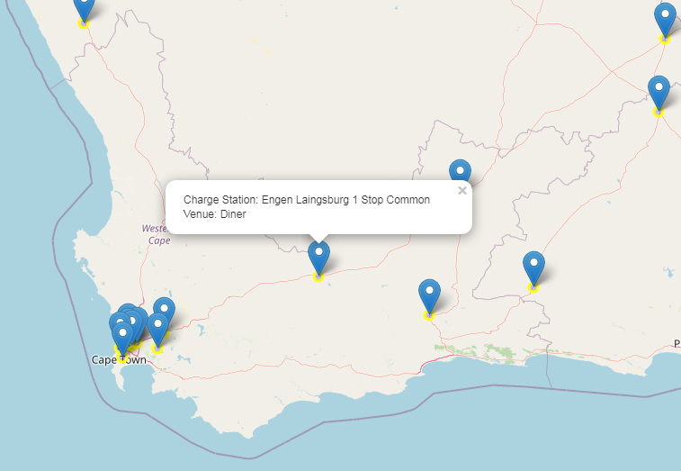

Figure 5: Charging point location label showing the station name and the most common venue type nearby

### Venues near charging points

The venues within a 200 metre radius of each charging point were plotted around the point. Venues were clustered showing the number of venues near the charging point. This gives the user an idea of how many amennities there are within walking distance of the point. Zooming in and clicking on the venue marker shows the name of the venue as a label.

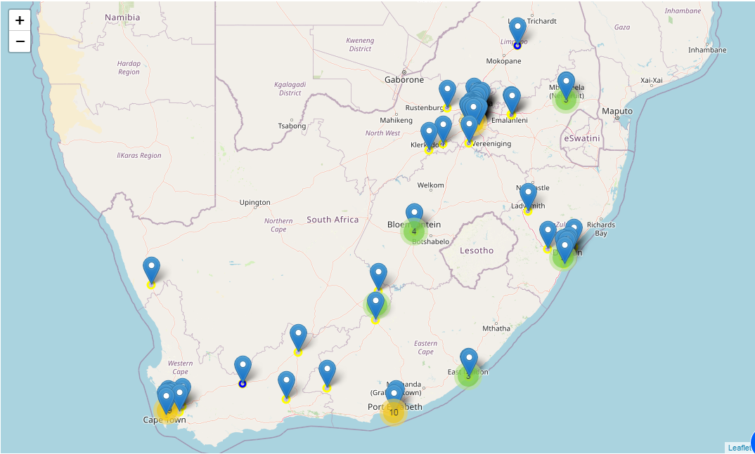

Figure 6: Map showing clustered venues near a charging point

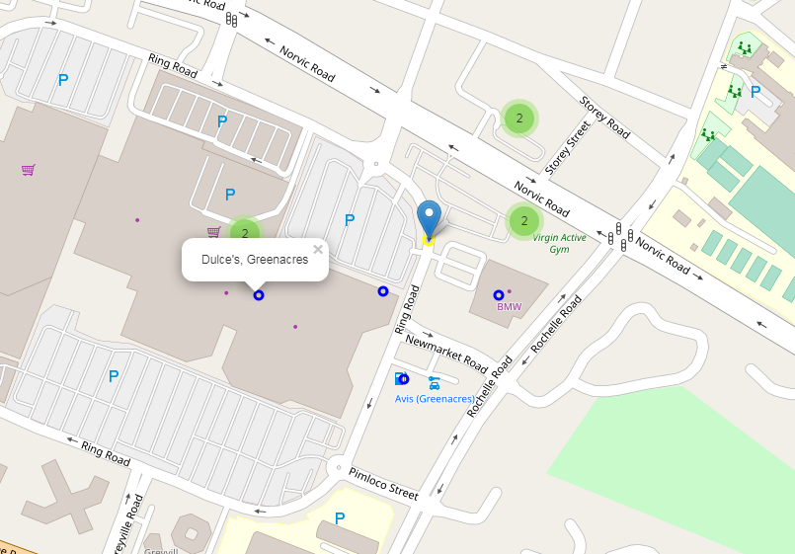

Figure 7: Zoom in image of venue label near a charging point

# Results discussion

## Data acquisition and integrity

The data used for the charging point locations consisted mainly of a list of charging points in RSA published in an online article. The list of points has not been updated since the article was published in 2017 which means the data points used did not fully represent the current EV charging point infrastructure in the country.

An attempt was made to improve the integrity of the data by adding charging point locations from the PlugShare website. This was done only to create a fuller overview of the charging points around the country by showing more markers along the major routes. It did solve the problem of having up to date charging point locations. For the purposes of this project’s problem statement, the solution was sufficient in showing how charging point location services can add useful information that can help the user plan their trip better.

## Charging points map

It was found that some of the charging points returned “Nan” for the most common venue type in the nearby vicinity. This could mean that either there are no venues within the 200 m radius or no venue types which occur more than once. This result could be improved by increasing the radius limit to 250 m, which is still within walking distance range. Further, a distance input could be added which allows the user to select the range used to determine the venues near a charging point.

The label marker display could be improved upon to show a pop-up breakdown of the the charging point name, its most common and nearby venues and some of the information about the charging point type, similarly to that shown on charging point location service providers.

## Solution application

In order to improve upon the solutions practical applicability, the following are some suggestions on how the idea can be improved upon in order to make it useful for everyday EV users on South African roads:

1. Get the latest and regularly updated data on the charging point locations in the region.
   1. This could be done by retrieving the data points from PlugShare or a similar site using a commercial license to access the API.
   2. Alternatively, the solution could be an added feature to one aforementioned site that already provides most of the other useful information.
2. If the option to retrieve the data from a site using a commercial license is selected, the following will be necessary in addition:
   1. Get information on the plug point type available at the location. This informs the user whether the plug point will be compatible with the EV and charger.
   2. Get the plug point usage history and current operation status from the service provider or user feedback and inputs.
   3. Get user ratings for the venues near the charging points and add that to the pop-up description.
   4. Improve on the interface display, as described in the charging point’s maps results discussion.
   5. Create a mobile access application for the ease of access for the user while they are on the road.

# Conclusion

The aim of addressing the problem of how EV users can spend their time while waiting for their vehicle to charge along their journey was partially fulfilled with the simplistic solution presented in this report. Resource constraints and the limited time available for the project meant that some aspect of the problem could not be fully addressed with this solution.The results discussion shows that much can still be done to improve on the practical applicability of the solution if it is to be used by EV drivers to assist with their trip planning.

# References

[1] K Khumalo. *Electric Vehicles: Market Intelligence Report 2019*. GreenCape. 2019

[2] S Malinga. *Electric vehicle charging station map goes live*. [Online]. Available: <https://www.itweb.co.za/content/WnxpE74DJQR7V8XL>

[3] EV Charge, Plugs. [Online]. Available: <https://www.evcharge.co.za/plugs.html>

[4] C Lilly. *EV connector types*. [Online]. Available: <https://www.zap-map.com/charge-points/connectors-speeds/>

[5] N Akabor. *EV Charge Stations in SA: How Many & Where?* [Online]. Available: https://www.cars.co.za/motoring_news/ev-charge-stations-in-sa-how-many--where/43476/